This text box is for guidance purposes only. Please erase this text box before final submission.
The project charter is something that the project manager produces very early in the project life cycle, typically right after the champion has responded positively to the initial pitch (called FRAMING EXERCISE, PITCH, PROPOSAL, EXECUTIVE SUMMARY, etc...) and has indicated that they will take the project to the Sponsor for formal review.
This document is the typical channel used to solidify and formalize support for the project within the sponsoring organization.
- It provides a means of guiding and/or controlling expectations.
- It helps to avoid social problems.
- It is the first (and best) opportunity to tell the sponsors, “Here is the CULTURE we need for this project to be a success”.
- It helps the Project Manager identify and then obtain all of the permissions and power necessary to do their job.
- It is the best means possible for the Project Manager to develop a common concept of the project across the organization.
The Project Charter contains the following sections:
  - Scope
  - Resource Availability
  - Change Control
  - PM Authority
  - Assumptions
  - Risks

SD5953 – PROJECT CHARTER – GROUP X

DATE: YYYY-MM-DD

GROUP #: NN

GROUP NAME: GROUP_NAME

Scope (Executive Summary)
This text box is for guidance purposes only. Please erase this text box before final submission.
The SCOPE (Executive Summary) section is your first, best chance to SELL your project to the Sponsoring Organization.
In this section you should outline the answers to the basic questions posed within this course, WHY, HOW and HOW MUCH in as convincing a manner as possible.

Resource Availability
This text box is for guidance purposes only. Please erase this text box before final submission.
The following resources are currently available to help pursue this project:

INFORMATION RESOURCES
FRAMING EXERCISE STORY BOARD UX DESIGN MOCKUP
WORKING PROTOTYPE POSTER

HUMAN RESOURCES
GROUP MEMBERS: MEMBER_NAME STUDENT ID
MEMBER_NAME STUDENT ID
MEMBER_NAME STUDENT ID
MEMBER_NAME STUDENT ID

ORGANIZATIONAL RESOURCES
CHAMPION(S): SUPERVISOR_1, SUPERVISOR_2

SPONSOR: SPONSOR_1

FINANCIAL RESOURCES
We currently have the following financial resources available:

- We have been allocated a budget of HKDN,NNN.NN per team member.
- The total budget for our project is HKDNN,NNN.NN.

TIME
We currently have identified the following time frame(s):

START: YYYY-MM-DD
FINISH: YYYY-MM-DD

TOTAL DAYS: NNN
DAYS CONSUMED: NNN
DAYS REMAINING: NNN

Change Control
This text box is for guidance purposes only. Please erase this text box before final submission.
This is the section that describes the methodology by which changes to the project are achieved:
- How changes are proposed
  - Where
  - How
  - By who

- How changes are considered
  - Where
  - How
  - By who

- How changes are approved
  - Where
  - How
  - By who

- How changes are integrated
  - Where
  - How
  - By who

- How changes are published
  - Where
  - How
  - By who

PM Authority
This text box is for guidance purposes only. Please erase this text box before final submission.
It is very important that everyone involved in a project understand who has authority to make decisions, who doesn't and how far that decision-making authority extends.
It is also important to have an arbitration process in the case of a serious internal difference of opinion (a “deadlock”).
Projects often have layers of authority. Everyone needs to know the chain of command so that they know who right person is to get specific approvals. An organization chart helps here.
Please remember to put your CHAMPION at the top!

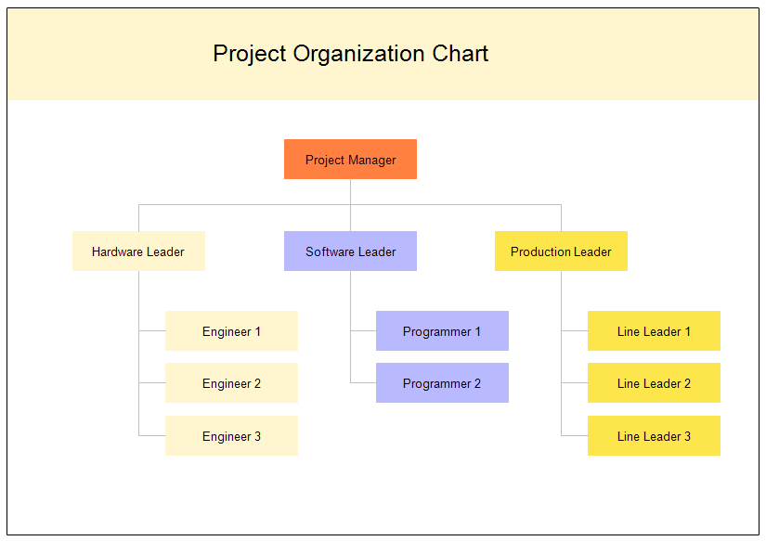

Assumptions
This text box is for guidance purposes only. Please erase this text box before final submission.
Making Assumptions in Project Management helps to phrase the project scope, which directly affects the schedule and budget.
Think of Assumptions as constant inputs with anticipated continuing availability as “normal” because these inputs are currently available, already assigned or committed to the project:
- The size and shape of things
- The conditions, durations and timing of things
- The availability of people, assets, materials and supplies

Risks
This text box is for guidance purposes only. Please erase this text box before final submission.
Think of Risks as a counter-point to Assumptions. What challenges, scarcity or upheaval could potentially threaten the major inputs previously considered available, assigned or committed to the project?
Risk analysis should be limited to those major inputs whose absence would jeopardize the entire project and lie in the realm of immediate possibility. Of course, this rule also applies to Assumptions.
Here’s an example of a risk mitigation grid, you should include something like this in your submission, though you may want to fine tune some of the column headings to suit your own perception of risks and how you might manage them.
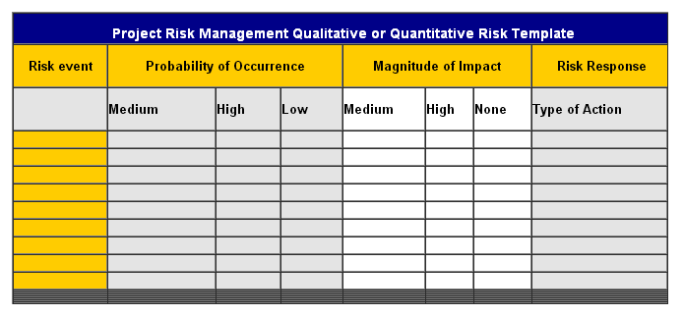

High Level Deliverables Network (HLDN)
This text box is for guidance purposes only. Please erase this text box before final submission.
The HLDN defines the scope of the project. Its completion leads to the Measure of Success and its nodes (or steps) describe the path from where we are now to where we want to be, which is the accomplishment of scope
Every entry in the HLDN is a qualitative deliverable coupled with a metric. The qualitative deliverable describes the goal, the metric describes the means by which the goal can be proven to have been achieved.
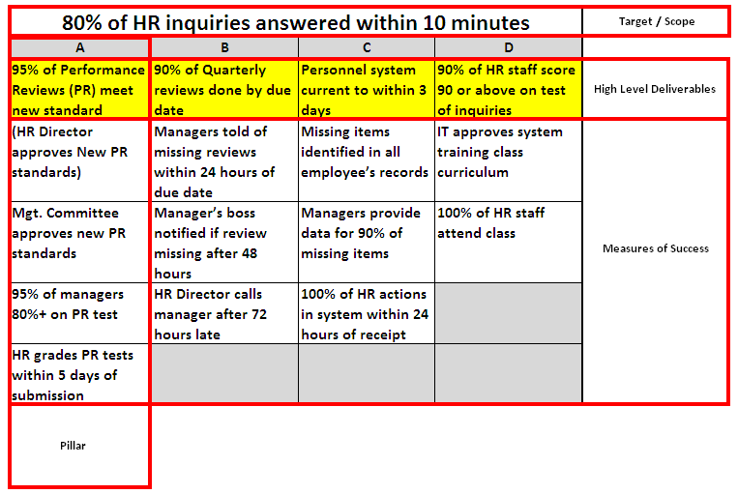

Supporting & Additional Information

This text box is for guidance purposes only. Please erase this text box before final submission.
Here is where any additional information (such as, for example, any previously generated, project proposal related information, screen shots, drawings, support letters, awards, etc…) may be appended to this document for additional credence and weight.

Here is your last opportunity to make your project really stand out.

